**Name: Zhandos Abdireshov**

**Group: BDA2004**

**E-mail: 201045@astanait.edu.kz**

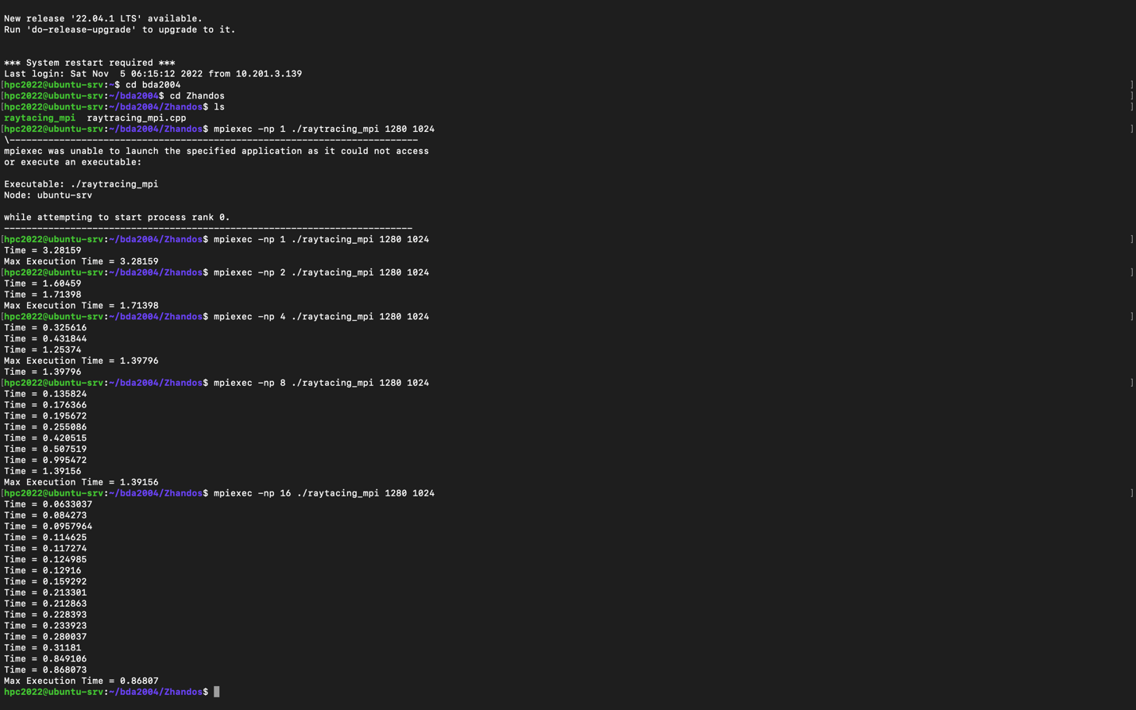

1. The execution time (to demonstrate how it depends on the number of processes)
2. Speedup: Speedup(N) = Time(1) / Time(N), N - number of processes
3. Efficiency: Efficiency(N) = Speedup(N) / N

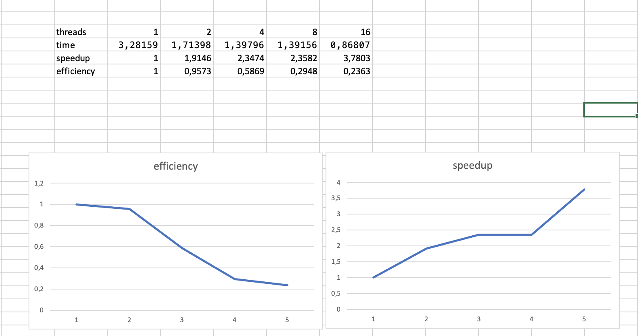



<https://github.com/qub1e/HPC/tree/main/ass4>

Conclusion:

As we can see in the table, by the increasing of the number of threads, speedup will be better, but efficiency will decrease. This shows that as the number of threads rises, the time it takes to finish a picture will rise too.